The running of the bulls. A practical use of concept mapping to capture expert knowledge.
By Fermín González and Jokin Zuasti
Introduction
The running of the Bulls is one of the most famous spectacles in the world (see http://www.sanferminencierro.com). It takes place every morning during the week of the annual San Fermin festivals, in Pamplona, Spain, celebrated between 7th and 14th of July. It is a very dangerous event (see http://www.doctordanger.com), especially for runners who are not sufficiently acquainted with the rules. Thus, year after year, most of those injured are foreigners. The accidents are very often the result of mistakes made by runners who are unaware of the risk involved and heedless of even a few basic guidelines. We realise that an event of this nature is influenced by a large number of variables of such a nature that they are very difficult to control. At the same time, however, we are convinced that a basic knowledge of these variables, especially among runners from abroad, would help to reduce the number of goring incidents and other injuries that take place every year, despite the warnings that are issued. What little information is available is in our view confusing, disorganised, linear, and invariably of a general nature. It is not possible through a municipal announcement to give more than a few basic and obvious tips. We believe that by making available information of a more specific, organised, and truly revealing nature, and underlining the real risks involved in the run, runners could be helped to monitor the risk more effectively. Access to the tacit knowledge of an expert in the intricacies of the running of the bulls might help us to improve the current state of affairs. The effectiveness of concept maps to illustrate/represent knowledge of that type has been amply tested (Cañas et al., 2000; Coffey et al., 2002; Ericsson et al., 2006; Novak, 1998). This study presents an example of access to the knowledge of an expert runner named Jokin Zuasti, one of the handful of runners acknowledged by the people of Pamplona to be the best and most experienced, and referred to by some of the locals as los divinos (the divine). Concept maps were therefore used in this context and, as we shall see, once again proved their effectiveness.

Procedure, material and methods. Methodology.
The approach used in this study relied on the method known as preSERVe (Coffey, Hoffman, Cañas & Ford, 2002) which is an iterative method of eliciting expert knowledge. It is a method that involves several stages: Prepare, Scope, Elicit, Render, Verify, and supports the construction of an informal but semantically rich representation of expert knowledge and the simultaneous creation and identification of critical supplementary resources that materially augment the representation. In parallel to this, we used concept maps to organise the information in a meaningful way and adapt the resulting knowledge model to enable users to interact with the information on the Internet.
The preparation stage was taken up with tasks such as selecting the subject matter and the expert who would be consulted and initiating contact with him. In the elicitation stage direct data was collected from the expert through the analysis of prior interviews (http://www.pymesdenavarra.es/,http://www.sanferminencierro.com/) and informal personal conversations. Further indirect data were obtained, by examining other documentary sources. This led to the creation of concept maps based on the analysis of the interview transcripts and the selection of data taken from several sources suggested by the expert, such as web sites, photographs, videos, texts, etc. The resulting maps were later checked by the expert. The material thus selected was used to create the knowledge model (see Figure 1).
Finally, the verification process consisted of a mechanical check to ensure that the menus linked to the various concepts dropped down correctly and, more importantly, the verification of the concepts and semantics of the various resources integrated into the final knowledge model. Decisions at all times were taken after negotiation and an exchange of views with the expert.
Results and discussion
Figure 1 presents a definition of the bull run with its characteristics and details of the people involved, and the sociological and geographical context in which it takes place. Also shown are the links attached to two different concepts on the map, one showing a scene from the run, the other the moment when the San Fermín festivals explode into life on July the sixth. The concept maps created from the basic knowledge of the expert are shown in Figures 2 and 3. Figure 2 shows the features the expert most strongly recommends runners to possess in order to avoid serious injury. There is a link to a photograph showing a runner at a moment of extreme danger, testing his capacity to react, handle the situation, and escape unscathed by standing still, waiting for the herd to pass and jumping over the fallen bull. Figure 3 is a concept map showing, again from the expert’s point of view, the most frequent dangers to which runners are exposed. Also shown are some links attached to key concepts, such as a goring incident, crowding and specific actions that constitute a violation of the rules. We have highlighted those features of the run that are known only to the expert and which, despite their enormous importance, are not included in sufficient detail in the official advice to runners.
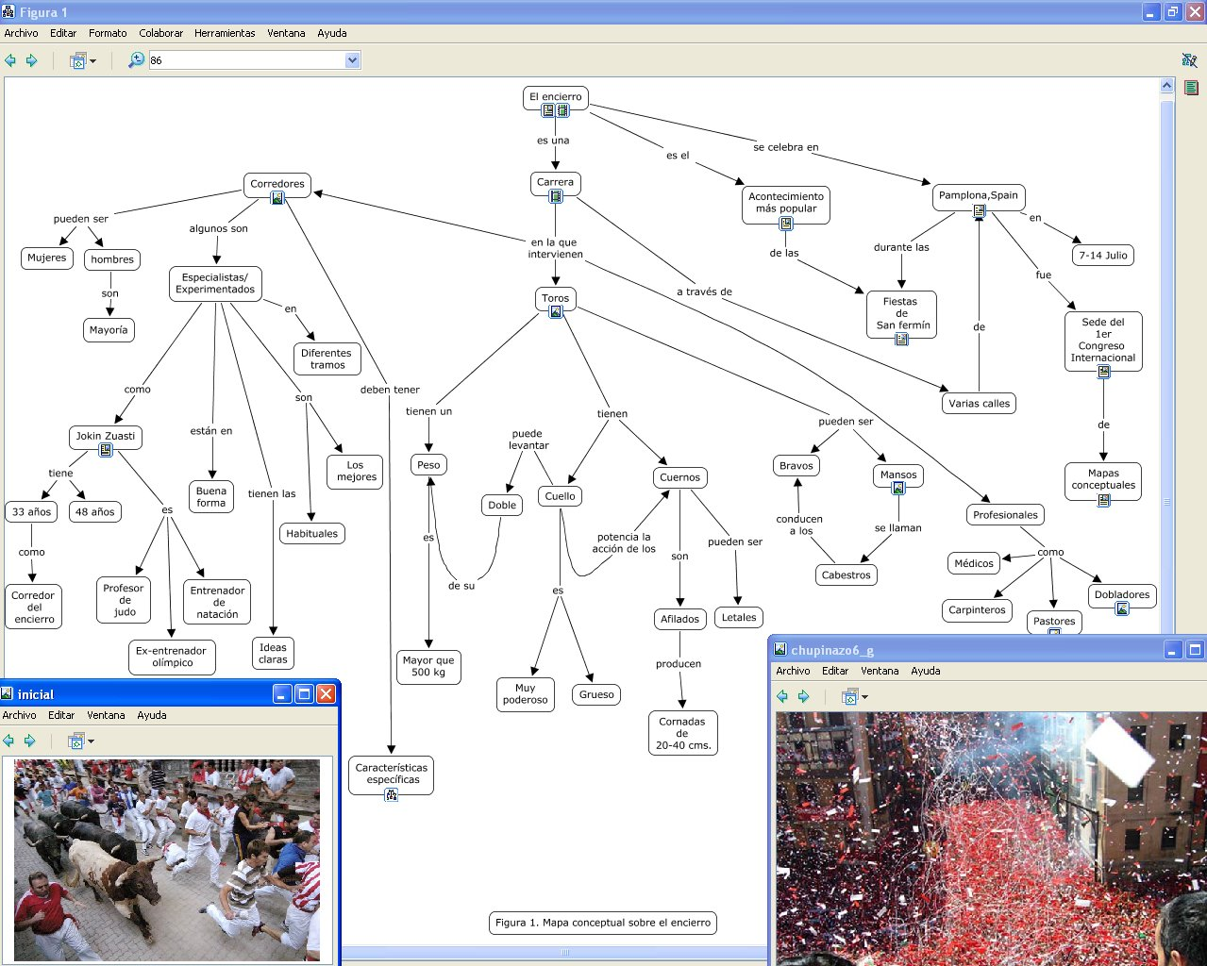

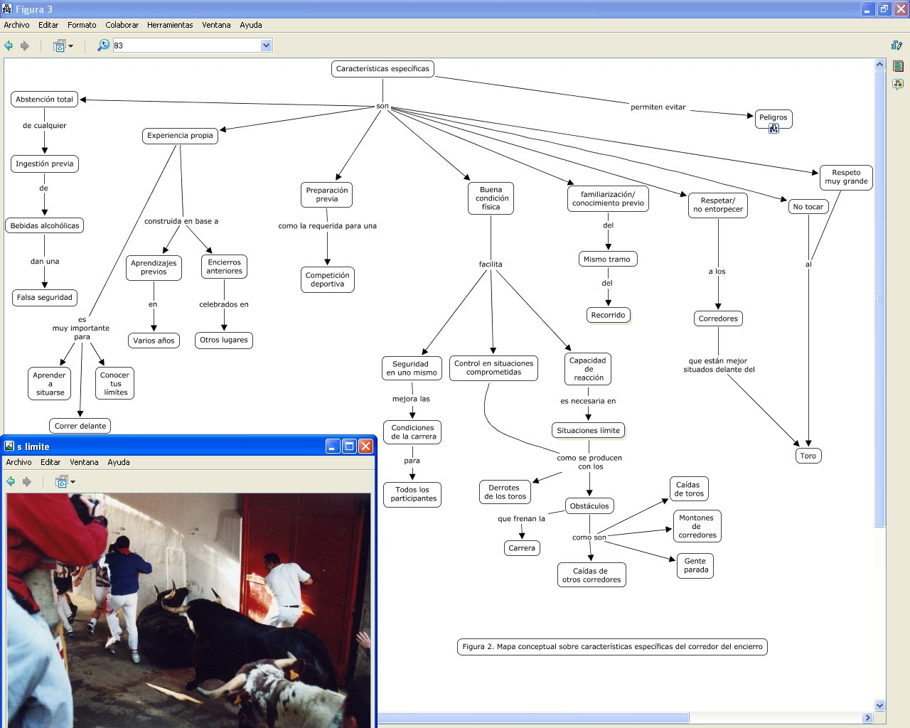

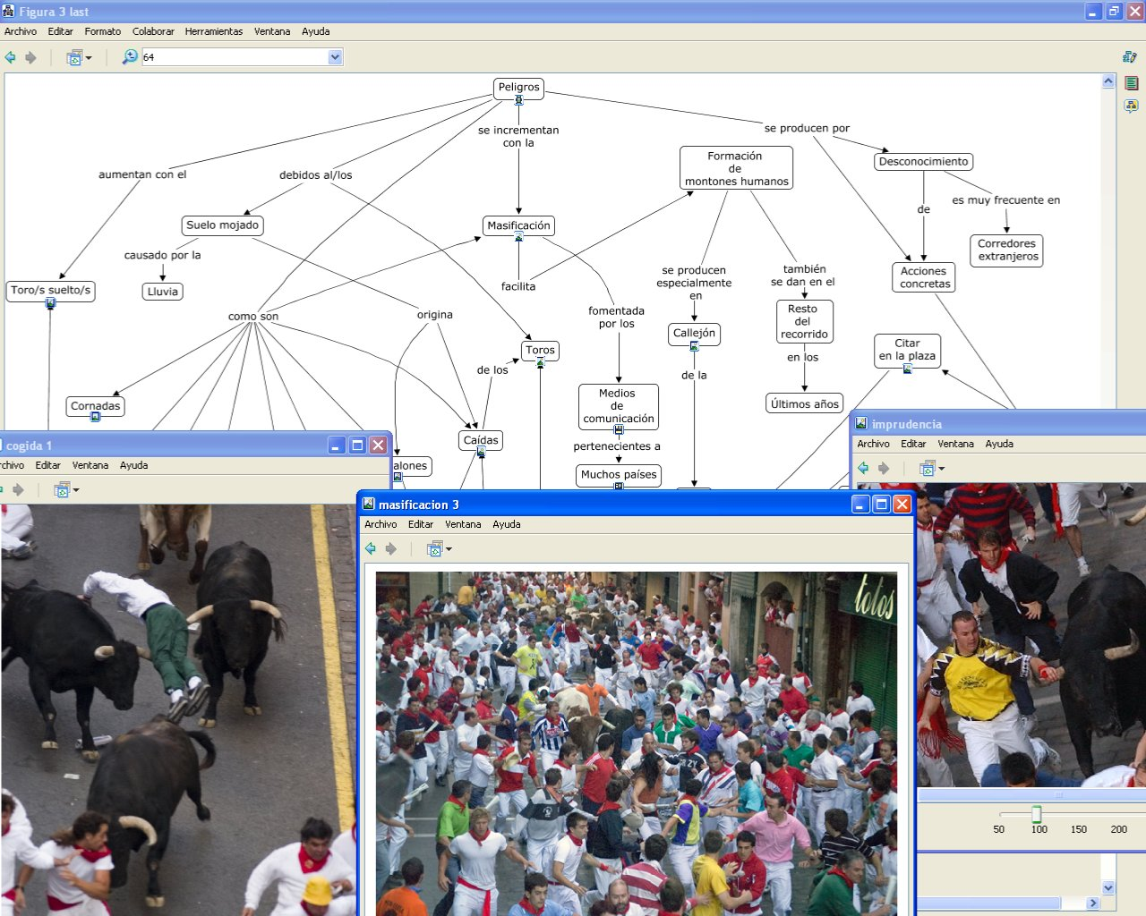
Conclusions
Analysis of the experience is allows us to conclude that:
-The expert reflected deeply on his own knowledge and the concept maps resulting from negotiation and joint decision-making helped him to reconsider his own views in depth and clarify them as required, calling on faculties he did not possess at the start of the experience.
-As might be expected, the experience revealed that many of the details elicited from the expert are missing from official propaganda and standard reports. They belong exclusively to the stored knowledge of the expert who has experienced them. These details, which now feature on the maps in Figure 2 and 3, are the most striking and the ones most likely to encourage change in the behaviour of runners and thereby help to reduce the risk to which they are exposed.
-The expert runner is endowed with an outstanding capacity for analysis and the ability to keep a cool head in the kind situations of extreme danger that are inevitable in the bull run. He is able to rise to whatever the occasion demands. Thus, in tricky or dangerous situations, such as other runners being gored by the bull, people irresponsibly inciting the bull, bulls straggling behind or otherwise separating themselves from the rest of the herd, etc. he is able to react appropriately, ensure that others follow the rules and find a way out of the problem.
-Since the expertise of the seasoned runner which is the fruit of years of experience, cannot be improvised, novice or less experienced runners, usually foreigners, need to be better informed with information of high significance potential, such as that emerging from this research. This will encourage them to imitate the responsible conduct of the expert, do as he does, and thus contribute to ensuring as far as possible that the event proceeds as it ought, and to reducing to the minimum the number of accidents to runners.
-These issues, which go unmentioned in the official propaganda, will be passed on to the authorities in charge of the organization of the run. The model can be made available to the public, in print or online, throughout the festival period and just before the bull run, to try to ensure that prospective runners are suitably informed
-Finally the knowledge model created as a result of this research might be put to debate among the various agents concerned (runners, the authorities, institutional representatives, the media, and other active social agents). Their conclusions might lead to the continuous improvement of the safety conditions associated with the bull-run.

References
Cañas, A. J., Ford, K. M., Coffey, J., Reichherzer, T., Carff, R., Shamma, D., & Breedy, M. (2000). Herramientas para Construir y Compartir Modelos de Conocimiento basados en Mapas Conceptuales. Revista de Informática Educativa, 13(2), 145-158.
Coffey, J. W., R. Hoffman, A. J. Cañas & K. M. Ford (2002), A Concept Map-Based Knowledge Modeling Approach to Expert Knowledge Sharing, IKS 2002- The IASTED International Conference on Information and Knowledge Sharing, November Virgin Islands.
Ericsson, K. A.; Charness, N.; Feltovich, P. J. & Hoffman, R.R.(Eds.)(2006). The Cambridge Handbook of Expertise and Expert Performance. Cambridge University Press: Cambridge, MA
Novak J. D. (1998). Conocimiento y Aprendizaje. Los mapas conceptuales como herramientas facilitadoras para escuelas y empresas. Alianza Editorial: Madrid.

